DEPLOY FLASK/PYTHON WEB APPLICATION BY USING AUTOMATION

JENKINS:

Jenkins is an open source automation server. It helps automate the parts of software development related to building, testing, and deploying, facilitating continuous integration and continuous delivery.

First create the ec2 instance with linux server and give the security group

Ssh-22,httpd-8080

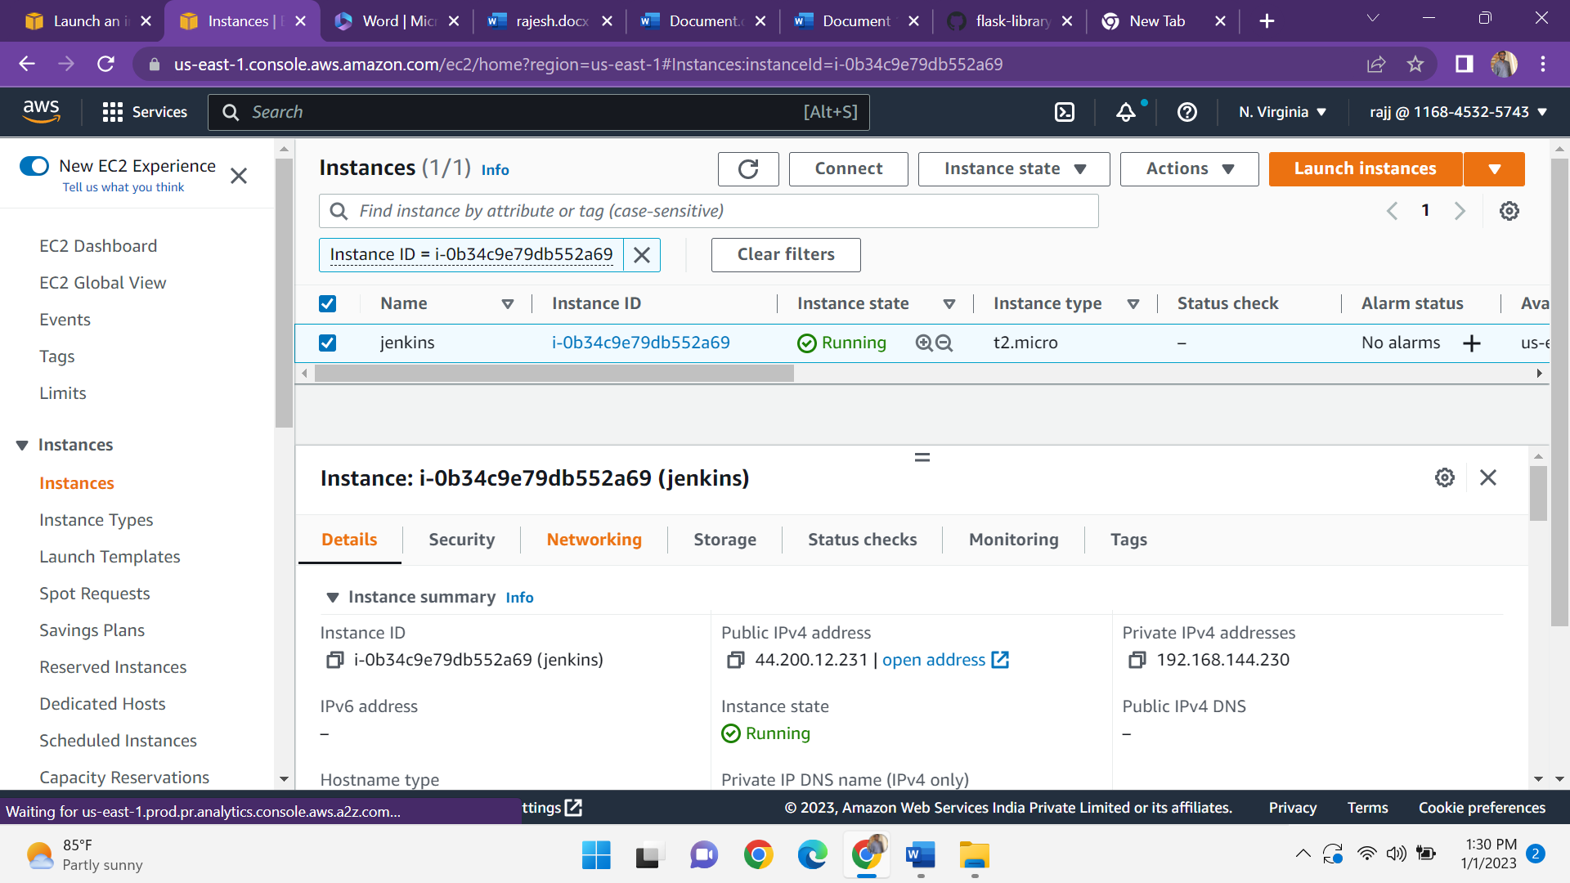

And then instance is connected to the terminal by copy the address

ssh -i ./keypair ec2-user@publicip address

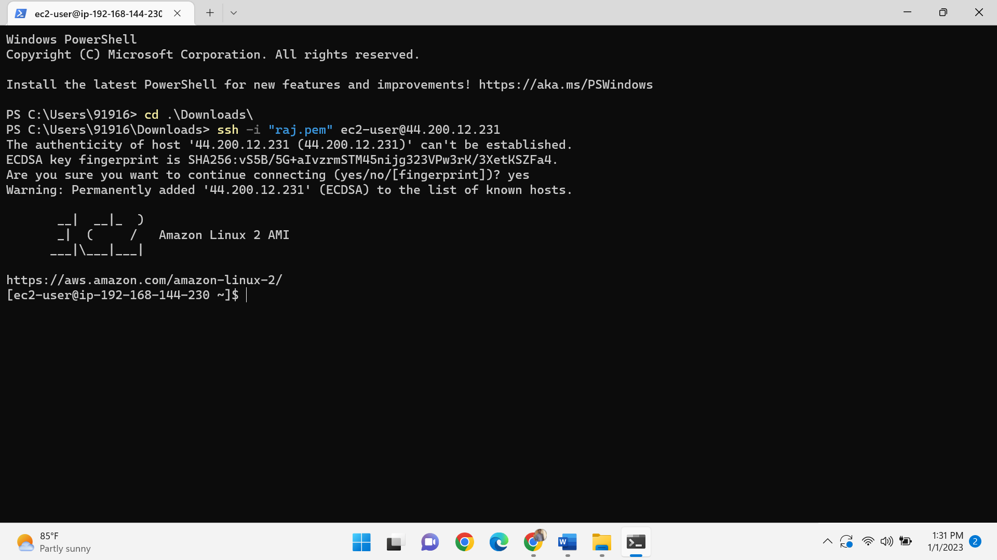

And install the java-11\* in terminal by using the following command

Sudo yum –y install java-11\*

after install the jenkins before installing jenkins we can install the packages

sudo wget -O /etc/yum.repos.d/jenkins.repo https://pkg.jenkins.io/redhat-stable/jenkins.repo  
  
sudo rpm --import https://pkg.jenkins.io/redhat-stable/jenkins.io.key  
  
sudo yum –y install jenkins

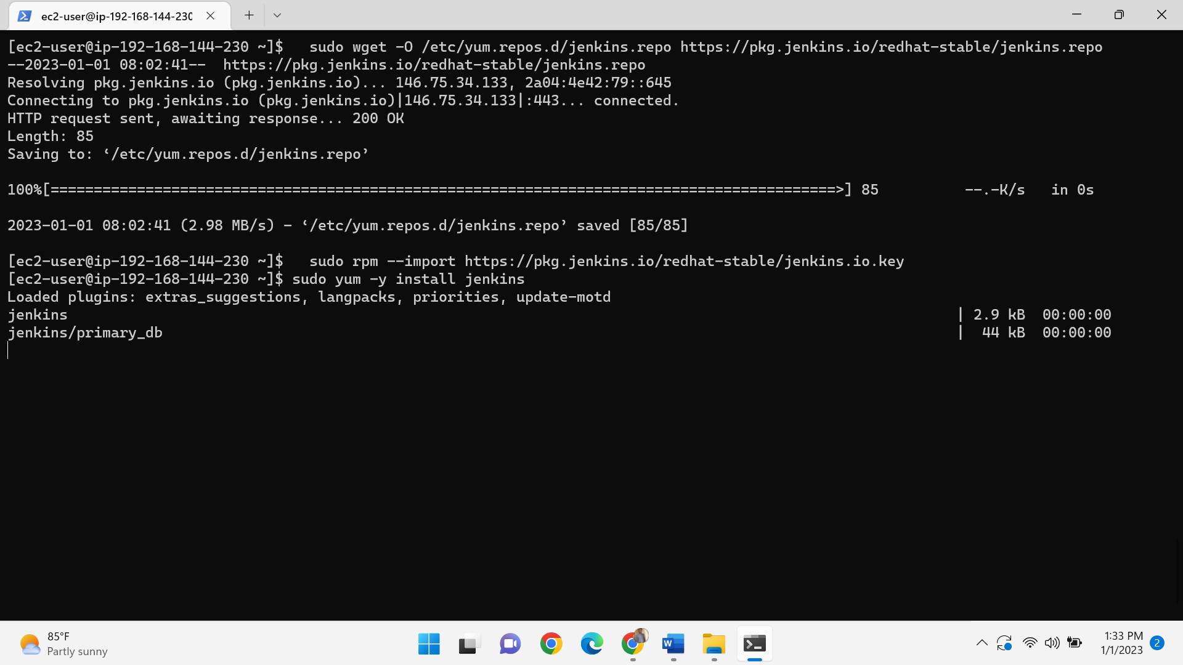

Start the jenkins-sudo systemctl start jenkins

Sudo systemctl enable jenkins

Copy the public ip address and paste it on browser-<pubip:8080>

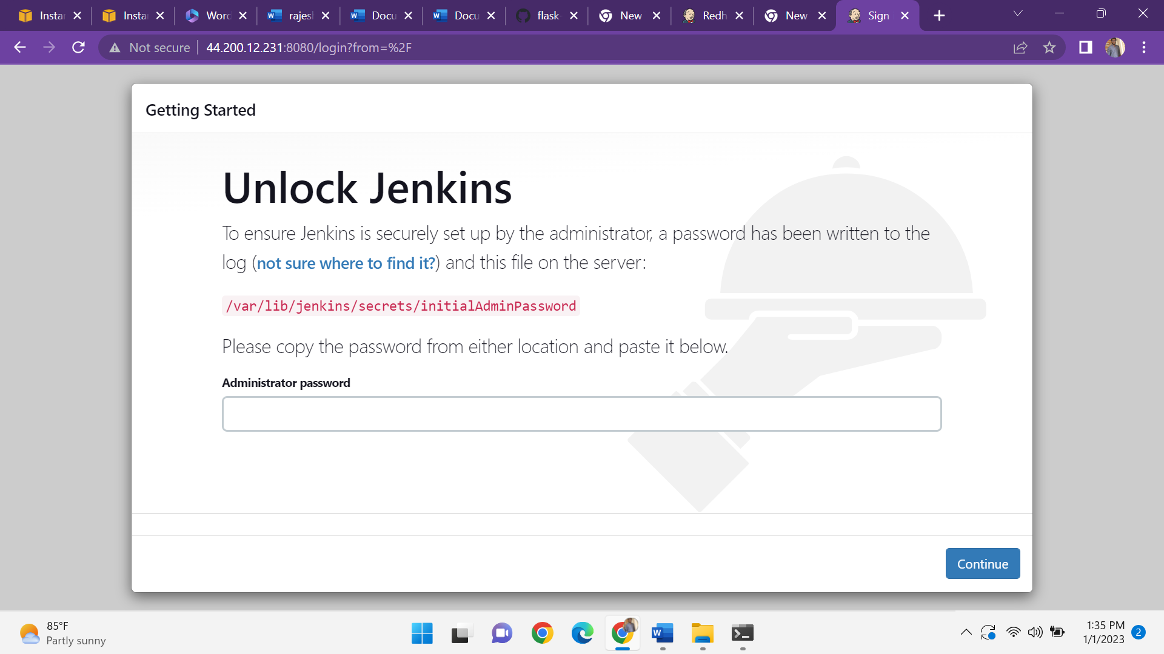

Give sudo cat /var/lib/jenkins/secrets/initialadminpassword

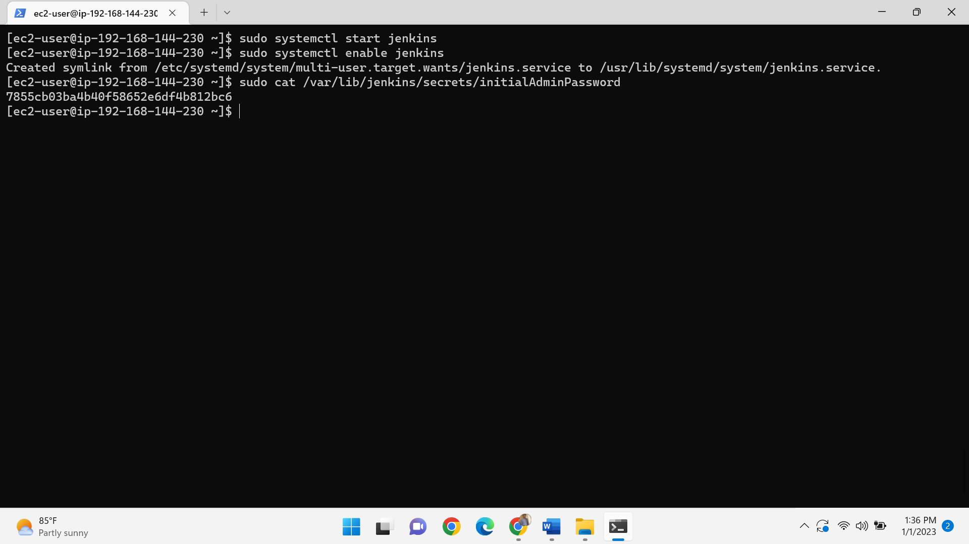

Copy the key and paste it on jenkins

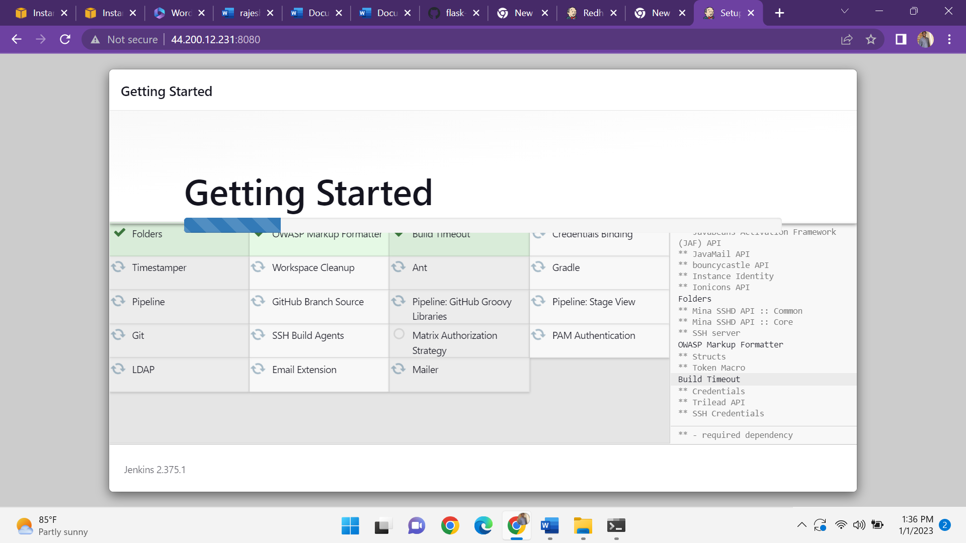

And after create the first admin user

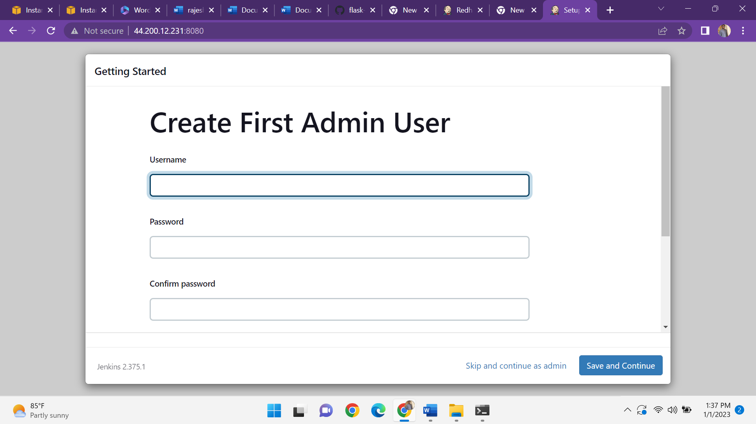

Jenkins is ready

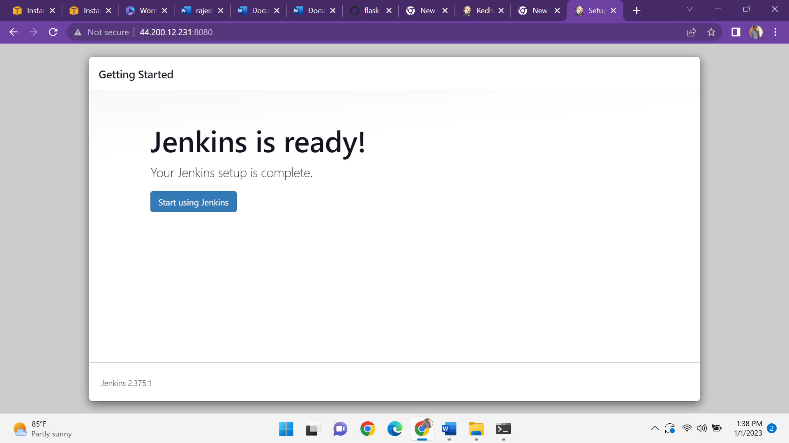

After create a job-1 git clone the repository from github save and click on build now.

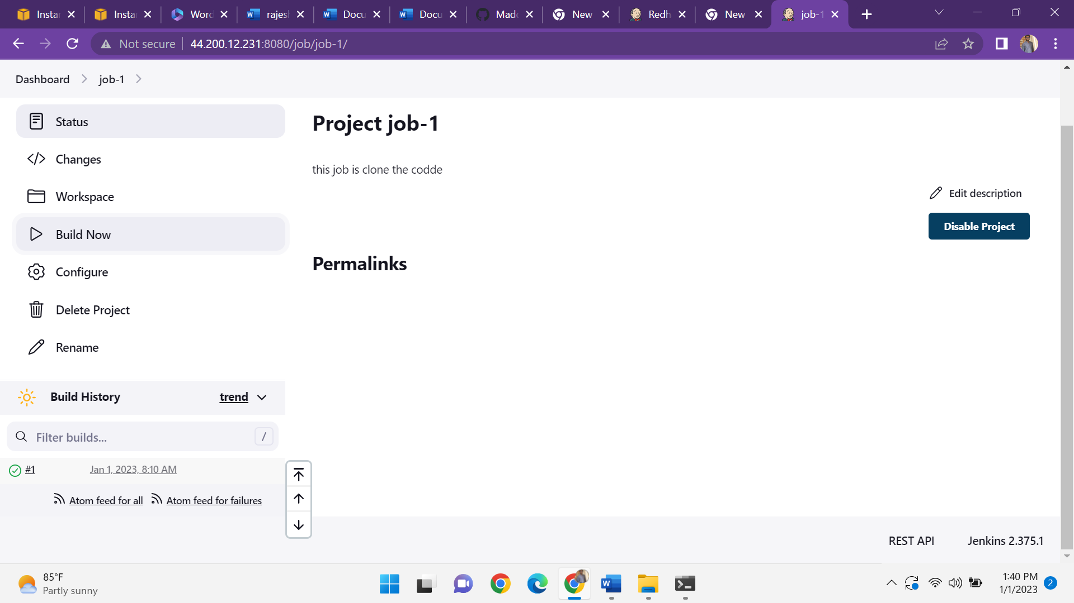

And after create a job-2 execute shell

Cd /var/lib/jenkins/workspace/job-2

Pip3 install –r requirements.txt

Python3 app.py

Save and click on build now

